**Omicron**

**Harshit Kumar Gupta**

**Shival Tiwari**

**Knit Sultanpur**



**Online Library Management System**

***Software Requirement Specification***

**On**

**“Online Library Management System”**

**Submitted By: Harshit Kumar Gupta**

**Shival Tiwari**

**Guided By: Mr. Avadhesh kumar**

**Team Name : Omicron**

**ACKNOWLEDGEMENT**

The satisfaction that accompanies that the successful

completion of any task would be incomplete without the

mention of people whose ceaseless cooperation made it

possible, whose constant guidance and encouragement

crown all efforts with success.

We are grateful to our project guide Mr. Avadhesh kumar

for the guidance, inspiration and constructive suggestions

that helpful us in the preparation of this project.

We also thank our colleagues who have helped in successful

completion of the project.

Harshit Kumar Gupta

Shival tiwari

**Table of Contents**

**1. Introduction**--------------------------------------------------------------------------

1.1 Purpose ----------------------------------------------------------------------------------- 4

1.2 Scope ------------------------------------------------------------------------------------- 3

1.3 Definitions, Acronyms and Abbreviations------------------------------------------- 5

1.4 References ------------------------------------------------------------------------------- 5

1.5 Technologies/Tools to be used-------------------------------------------------------- 5

1.6 Hardware / Software Requirements------------------------------------------------- 7

1.7 Overview -------------------------------------------------------------------------------- 8

**2. Overall Description** ------------------------------------------------------------------ 9

2.1 Use -Case Model Survey--------------------------------------------------------------- 9

2.2 Architecture diagram & Database Design------------------------------------------ 12

2.3 Assumptions and Dependencies ---------------------------------------------------- 18

**3. Specific Requirements** ---------------------------------------------------------- 18

3.1 Use-Case Reports -------------------------------------------------------------------- 18

3.2 Supplementary Requirements------------------------------------------------------- 29

**4. Key Features -------------**---------------------------------------------------------- 30

4.1 Use of XML -------------------------------------------------------------------------- 30

4.2 Plus Points in Design ---------------------------------------------------------------- 30

**1.Introduction:-**

**1.1 Purpose :**

IT enabled academic world aims at the computerization of academic process, to divert the attention from the trivial details of a college management to better aspects of education, leading to a better education system. This project is aimed at developing an online Library Management System for the college library. This project is an Intranet based application that can be accessed throughout the campus. This system can be used to search for books/magazines, reserve books, find out who is having a particular book, put in requests to buy a new book etc. This is one integrated system that contains both the user component and the librarian component. There are features like email notifications/reminders, report generators etc in this system. A better study Authorities can have a graphical analysis of the working system too.

**1.2 Scope :**

* Secure online registration and authentication of all users.
* Profile management facilities with customizable skins.
* E-book upload feature for students.
* End of the day feedback of student about book.
* Graphical analysis for the authorities to efficiently manage the resources.
* Hierarchical structure for different users, to ease administration.
* Central repository in the form of a database, which is only accessible by the Data Manager.
* FAQ section for helping the users.
* A separate module named RFC (Request for A Change) is provided to bridge the communication gap between authorities and end users. It provides provision for every user to make any changes in the administration via posting suggestions on it.
* Guests have an option of visiting metadata and history reservation of any book to know more about that.
* A Person should be able to login to the system through the first page of the application and change the password after login into the system.
* See the status of the books/journals borrowed/reserved by him and the respective due dates and other relevant details.
* Search for a particular book/journal based on the name of the book/name of the author/subject/etc and also list for books/journals based on the name of the author/subject etc.
* Place requests for purchasing new books to the library, by giving details about the name of the book, name of the author, publisher.
* See who has borrowed a particular book/journal and when is the due date for the same.
* Cancel the reservation made earlier for a particular book / journal.
* Reserve a particular book/journal borrowed by others currently.
* As soon as a reservation is made for a particular book, an automatic mail should be sent to the person who made the reservation about the details. Then, a mail should be sent to people who are having the book currently, stating a reservation has been made on that book.

**1.3 Definitions, Acronyms and Abbreviations :**

* **JSP :** Java Server Pages – A leading server side technology.
* **JVM :** Java Virtual Machine – needed for running java programs.
* **HTML -** Hypertext Markup Language used for creation of static web pages.
* **J2EE -** Java 2 Enterprise Edition – Platform for development of multitier java applications
* **XML -** Extensible Markup Language.
* **DB2 -** DB2 Database Server
* **WAS CE –** WebSphere Application Server Community Edition-Application Server
* **HTTP -** Hypertext Transfer Protocol –transaction oriented client- server protocol
* **HTTPS -** Secure Hypertext Transfer Protocol – Uses Secure Socket Layer for secure transmission of data.
* **AJAX –** Asynchronous Java Script and Extensible Markup Language.
* **RSS –** Really Simple Syndication

**1.4 References :**

* IEEE SRS Format
* Object Oriented Systems Development –Ali Bahrami (McGraw-Hill)
* Software Engineering – A Practitioner’s Approach – Roger S. Pressman – (McGraw-Hill)
* Project specification requirement (provided by IBM)
* Database System Concepts – Abraham Silberschatz
* JAVA –Complete Reference(Herbert Schildt)
* Servlet & JSP –Head First

**1.5 Technologies /Tools to be used :**

**Design Tools :**

* Altova UML tool
* Smart Draw
* Star UML tool
* Rational Rose plugin for Eclipse

**Programming Tools :**

* RAD
* Macromedia Dreamweaver

**Technologies :**

**User Interface :**

* **JSP/Servlets** – Basic text files with Java code in HTML page or vice versa.
* **AJAX –** Provides server interaction without page reloading.
* **XML-** Use of XML as a data type in the database for RFC Module.

**Middleware :**

* **DB2 –** A high-end database server for enterprise purposes.
* **WAS CE –** A user-friendly application server which supports all the modern web development practices.

**Other essential technologies and Tools:**

* **Eclipse SDK -6.0**
* **RSS –** Providesdynamic updates to the clients in an easy fashion**.**
* **Tivoli -** It provides an intelligent infrastructure management, to manage and enhance the business value of the client’s IT system**.**

**Functional components of the project**

Following is a list of functionalities of the system. More functionalities that you find suitable can be added to this list. And, in places where the explanation of functionality is not adequate, you can make proper assumptions and proceed.

There are registered people in the system (students, faculty, librarian et al). Each one of them may have some exclusive privileges .

* A person should be able to
* login to the system through the first page of the application
* change the password after logging into the system
* see the status of the books/journals borrowed/reserved by him and the respective due dates and other relevant details
* search for a particular book/journal based on the name of the book/name of the author/subject/etc and also list for books/journals based on the name of the author/subject etc
* reserve a particular book/journal borrowed by others currently
* cancel the reservation made earlier for a particular book/journal
* see who has borrowed a particular book/journal and when is the due date for the same
* place requests for purchasing new books to the library, by giving details about the name of the book, name of the author, publisher etc.

* get help about the LiMS on how to use the different features of the system
* As soon as a reservation is made for a particular book, an automatic mail should be sent to the person who made the reservation about the details. Then, a mail should be sent to people who are having the book currently, stating a reservation has been made on that book.

* Automatic mails should be sent to the users about the expiry of due dates for the books/journals borrowed by them. An advance notification (say, 4 days before the expiry of the due date) should be sent as well.
* The librarian should be able to
* include new books/journals or remove some books from the inventory
* add new users to the system
* see the purchase requests for new books and be able to approve/reject the same

**Steps to start-off the project**

The following steps will be helpful to start off the project.

* Study and be comfortable with technologies such as Active Server Pages/HTML and SQL server. Some links to these technologies are given in the ‘Guidelines and References’ section of this document
* Make a database of books/journals
* Make a list of students/faculty who would be using the system
* Create the front-page of the system giving a brief description about the system and a login box.
* Create the help-pages of the system in the form of Q&A. This will help you also when implementing the system.

Create other sub-systems like automatic notification, screens for various functions (like reservation, cancellation of reservation, purchase request for new books, approval page for the librarian etc).

**1.6 Hardware / Software Requirements :**

|  |  |  |  |  |
| --- | --- | --- | --- | --- |
| **Client Side** | **Operating System** | **Processor** | **Disk Space** | **RAM** |
| Browser (Internet Explorer, Mozilla Firefox, Opera) | ANY | Pentium II onwards, AMD Opteron onwards | 1 GB | 64 MB |

|  |  |  |  |  |
| --- | --- | --- | --- | --- |
| **Server Side** | **Operating System** | **Processor** | **Disk Space** | **RAM** |
| Websphere Application Server v 7.0 | Windows(Development End), ANY other can also be used | Pentium IV @500 MHz onwards, AMD Opteron onwards | 2 GB | 512 MB (minimum),  1 GB (recommended) |
| Database Server DB2 v 9.5 | Windows (Development End), ANY other can also be used | Pentium IV @ 500 MHz onwards, AMD Opteron onwards | 2 GB + data storage | 512 MB (minimum),  1 GB (recommended) |
| IBM Tivoli | Windows  (Development End), ANY other can also be used | Pentium !V @ 500 MHz onwards, AMD Opteron onwards | 10 GB+  Data storage | 1 GB (minimum)  2 GB  (recommended) |

**User Characteristsics :**

* Should have a basic knowledge of English.
* Should be familiar with basic concepts of computer including web browsing and file uploading.

**Design Constraints :**

* Administrator has no privilege to create a new user type.
* Manual allotment of books to the students and teachers to which are left unallocated during the book allocation.
* Only HTTP / HTTPS protocols are supported.

**1.7 Overview**

SRS includes two sections overall description and specific requirements:-

* Overall description will describe major role of the system components and interconnections.
* Specific requirements will describe roles & functions of the actors.

**2 Overall Description**

**2.1 Use Case Modelling:-**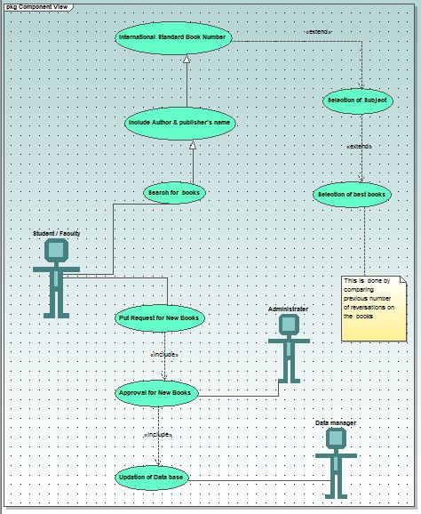

**Users:**

* **Student:-**
* **Download e-books /study material:-** A Student can download the e-books and study material posted by the any student faculty and which are updated on regular basis.
* **Post Feedback:-**A Student can post feedback on any book.
* **View Feedback:-**A student can also view the feedbacks posted by other students.
* **Search for any book:-** A student can search any book on the bassis of Name of book ,Author of book ,ISBN NO OF Book .
* **View Status of Book:-** A student can view the status of books.
* **Request for any book:-** A student can request for purchasing book that is not in library or in few numbers.
* **Registration:-**A student would have to register for the library to get ID for it.
* **View Profile:-**A student has also the rights to view the profiles of
* other students and faculty.
* **Manage Profile:-**A student can manage his profile.
* **Faculty:-**
* **Upload e-books /study material:-** A Faculty can upload the e-books and study material for the any student and which are updated on regular basis.
* **Post Feedback:-**A Faculty can post feedback on any book.
* **View Feedback:-**A Faculty an also view the feedbacks posted by other students.
* **Search for any book:-** A Faculty can search any book on the bassis of Name of book ,Author of book ,ISBN NO OF Book .
* **View Status of Book:-** Faculty can view the status of books.
* **Request for any book:-** A Faculty can request for purchasing book that is not in library or in few numbers.
* **Registration:-**A Faculty would have to register for the library to get ID for it.
* other students and faculty.
* **Manage Profile:-**A Faculty can manage his profile.
* **View Profiles:-**A faculty can view the profiles of the students and other faculties.
* **Data Manager:-**
* **Manage Profile:-** Data manager can manage his profile and update changes on it.
* **View all details:-**The data manager has rights to view any details on the website.
* **Manage approved changes:-**The data manager would have to modify the database according to the changes approved by the dean.
* **Approve request for any book:**- Data manger can approve requerst of any book.
* **Manage books:**- Data manager can manage books by knowing the status of any book.
* **Send E-mail regarding delivery of book:-** Data manager can send E-mail regarding the status of book.
* **Dean:-**
* **Manage Profile:-** The dean can modify and manage his profile.
* **View all details:-**The dean has the rights to view each and every detail on the website.
* **Approve changes:-**All the recommended changes before there implementation would have to be approved by the dean.
* **Backup of data:-**The dean is responsible to manage the backup of data.
* **Approve Request of any book:**- Dean can approve the request of any book.
* **Author and Publisher:-** 
  + - * **View Profile:-**They would have the privileges to view the profile of the students and the faculties.
      * **Suggest for any book:**-they can suggest any book for students and faculty.
* **Guest:-**
* **View Profile:-** Guest would have the privileges to view the profile of the students and the faculties.

|  |  |  |  |  |
| --- | --- | --- | --- | --- |
| **No.** | **Requirement** | **Essentialor Desirable** | **Description of the Requirement** | **Remarks** |
| RS1 | The system should have a login | Essential | A login box should appear when the system is invoked. | The logins are assigned by the admin |
| RS2 | The system should have help screens | Essential | Help about the various features of the system should be provided in sufficient detail in a Q&A format. | In addition to the features of the system, a note on what are the supported facilities, who are the corresponding facility-heads etc should also be there. |
| RS3 | The system should ‘lock’ the login id if wrong password is entered 3 times in a row | Desirable | This feature will improve the robustness of the application | Since the application is going to be used only by the people inside the campus, this feature is not essential. However, if time is there, this will be implemented. |
| RS4 | The user should be able to reserve a particular book/journal | Essential | The user should be able to reserve a book/journal that is listed in the library database | This is a basic requirement which has some additional requirements like email notification about the reservation made etc |
| RS5 |  |  |  |  |

**2.2 Architecture Diagram :**

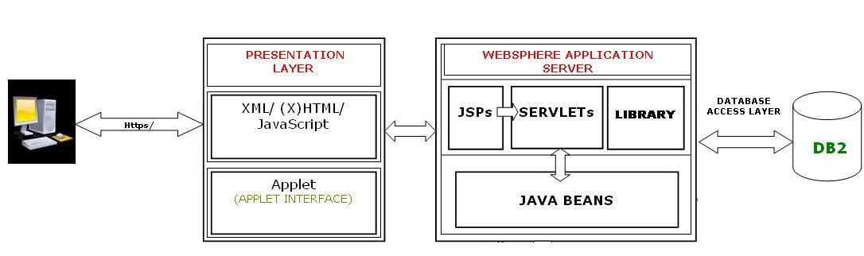

The above diagram basically depicts what is the architecture in the whole processing of our project that we have used. It clearly shows all the layers and what all layers are composed of. Each components are self ecxplanatory and hence are not explained further.

The architecture of the whole project is based on the 4+1 view of the rational approach:-

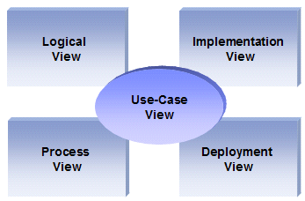

**Logical view**

**Audience**: Designers.

**Area**: Functional Requirements: describes the design's object model. Also describes the most important use-case realizations.

**Related Artifacts**: Design model

**Process view**

**Audience**: Integrators.

**Area**: Non-functional requirements: describes the design's concurrency and synchronization aspects.

**Related Artifacts**: (no specific artifact).

**Implementation view**

**Audience**: Programmers.

**Area**: Software components: describes the layers and subsystems of the application.

**Related Artifacts**: Implementation model, components.

**Deployment view**

**Audience**: Deployment managers.

**Area**: Topology: describes the mapping of the software onto the hardware and shows the system's distributed aspects.

**Related Artifacts**: Deployment model.

**Use Case view**

**Audience**: all the stakeholders of the system, including the end-users.

**Area**: describes the set of scenarios and/or use cases that represent some significant, central functionality of the system.

**Related Artifacts** : Use-Case Model, Use-Case documents.

**Data view (optional)**

**Audience**: Data specialists, Database administrators

**Area**: Persistence: describes the architecturally significant persistent elements in the data model

**Related Artifacts**: Data model.

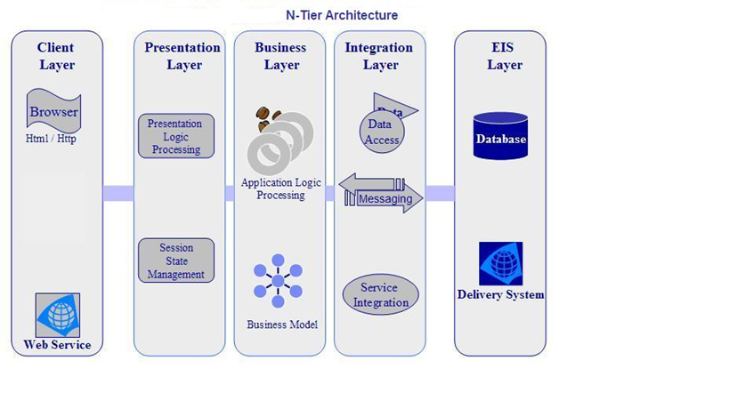

The layering model is based on a responsibility layering strategy that associates each layer with a particular responsibility.

This strategy has been chosen because it isolates various system responsibilities from one another, so that it improves both system development and maintenance.

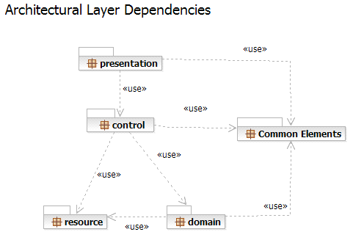

Each layer has specific responsibilities.

* The **presentation layer** deals with the presentation logic and the pages rendering
* The **control layer** manages the access to the domain layer
* The **resource layer** (integration layer) is responsible for the access to the enterprise information system (databases or other sources of information)
* The **domain layer** is related to the business logic and manages the accesses to the resource layer.
* The **Common Elements** **layer** gathers the common objects reused through all the layers

**Deployment View Architecture of the Project:**

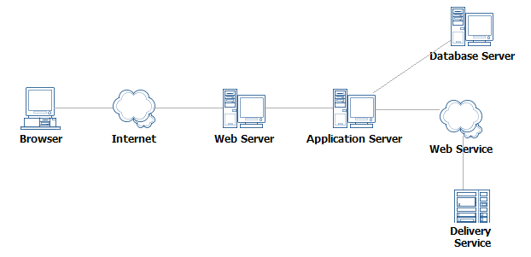

**E-R ( Entity Relationship )Diagram**:-

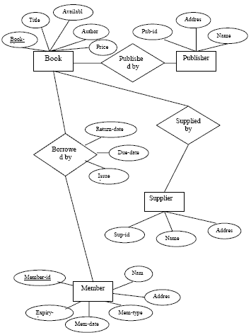

The E-R Diagram shows all the basic entities required in the project and the relationships existing between them. The E-R model has covered all the dependencies and the sharing of the data attributes between the entities.

**2.3 Data Flow Diagram (D F D):**

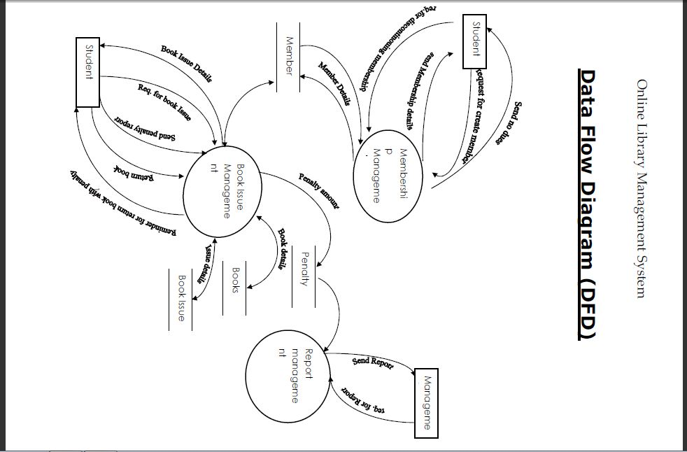

**2.4 Assumptions and Dependencies :**

* By default, an Administrator account is created, who will further create a Data Manager account on the first login itself.
* Users are limited to Administrator, Data Manager, Faculty, Student and Guest.
* In case the timetable generation could not allocate a subject and room for a class, the Data Manager has to manually do it ; though he will be aided by the algorithm.
* **Deployment Diagram**

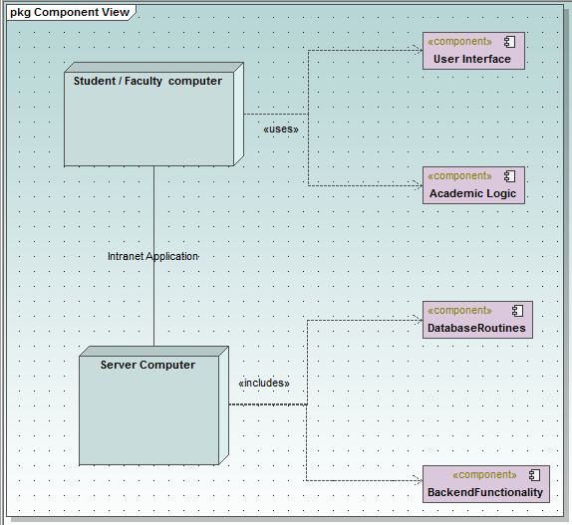

* **3. Specific Requirements**

**3.1 Use case Reports:-**

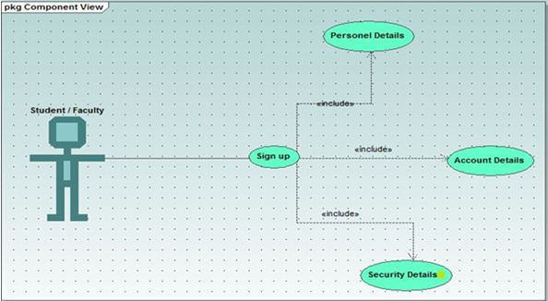

**Name of use case:** Registration

**Description:** Lets new users that is students and faculties to register themselves with the omicron website.

**Preconditions:**

*  The user has connected to the omicron web interface.
*  He has his id with himself.

**Normal flow of events:**

* The user logs in.
* The user fills his details.
* The account has been created.

**Alternate flow of events:** None.

**Post Condition:** None.

**Name of use case:**  Manage Profile

**Description:** Lets registered users to manage their profiles to update changes and upload image.

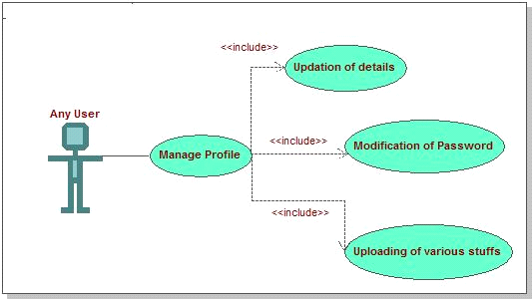

**Preconditions:**

*  The user is logged in.
*  The user provides valid information.

**Normal flow of events:**

* The user logs in.
* The user fills his details.
* Updates and saves the changes.

**Alternate flow of events:** None.

**Post Condition:** None.

**Name of use case:** Approval of changes

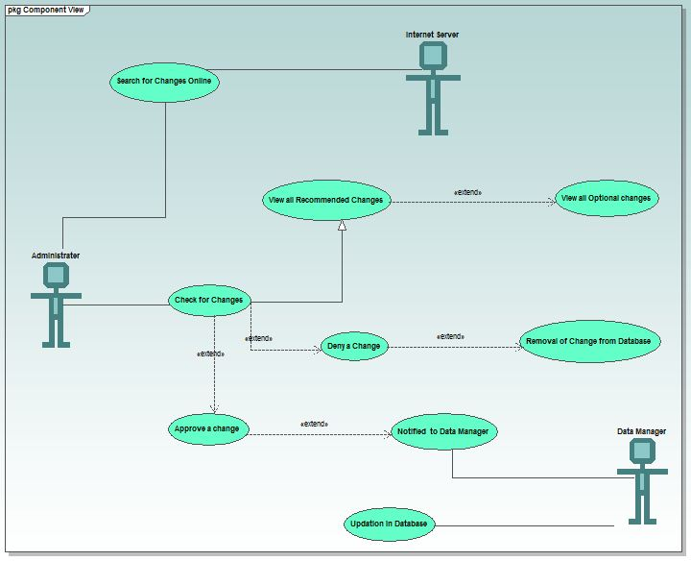

**Description:** Lets admin/dean to approve the recommended changes by the faculty and the data manager.

**Preconditions:**

*  The admin is logged in.
*  There have been some changes recommended for the admin to approve.

**Normal flow of events:**

* The admin logs in.
* He checks changes details.
* Approves the appropriate one’s.

**Alternate flow of events:** None.

**Post Condition:**

* The data manager logs in.
* He views the approved changes.
* He modifies them in the most appropriate way.

**Name of use case:** Order books .

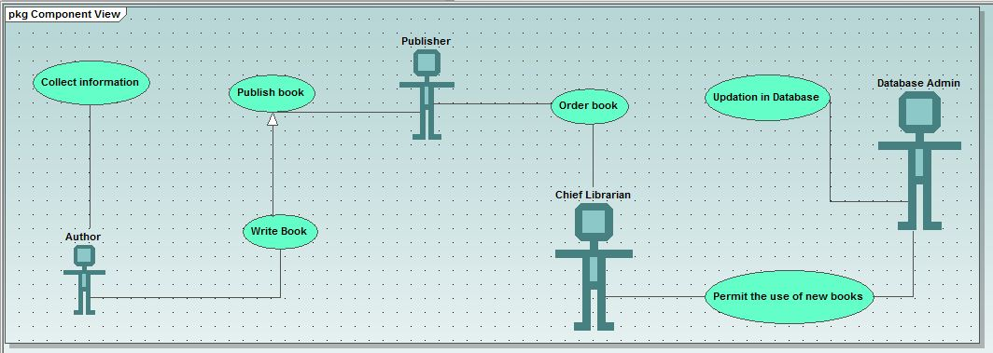

**Description:** This involves the order of books to publisher by collage authority.

**Preconditions:**

*  The data manager logs in.
*  See request for books.
* He has to feed in the database all the details.

**Normal flow of events:**

* The data manager logs in.
* He fills in the required details.
* Order books

**Alternate flow of events:** None.

**Post Condition:**

* If some ambiguities are found then he has to manually generate the time table.
* **Name of Use Case :- Selection of books**

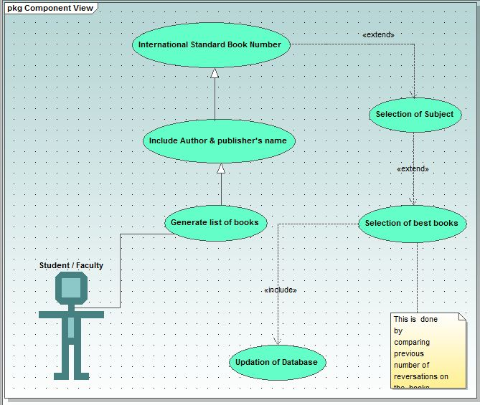

* **Name of UseCase :- Sending E-Mail**

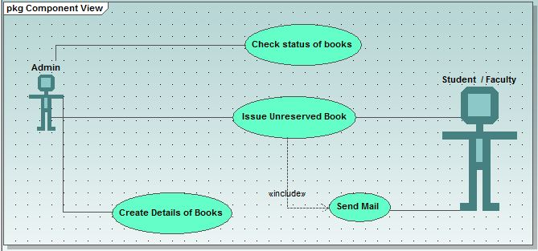

* **CLASS DIAGRAMS :-**

BOOK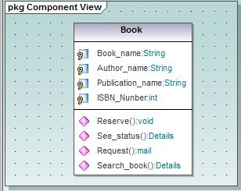

* **Relation Between Classes As Student/Faculty ,Book and Author**

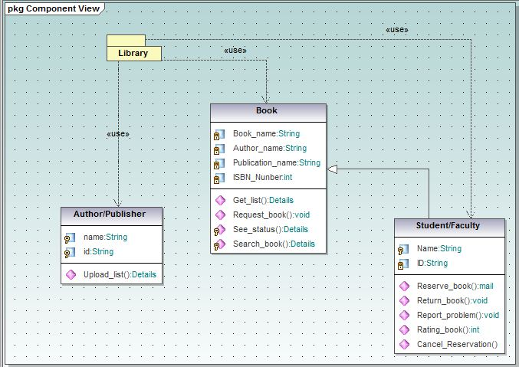

**Activity Diagrams:-**

**Name of activity: -**Selection/Searching of BOOks

**Description:** The first step in the library.

**Preconditions:**

*  The data manager has filled in all the details.
*  The data manager is logged in.

**Alternate flow of events:** None.

**Assumptions:-** Student /Faculty Know some Key data about booksuch as-

1. Name of book
2. Name of Author
3. Name of Publisher
4. I.B.S.N. number of book

.

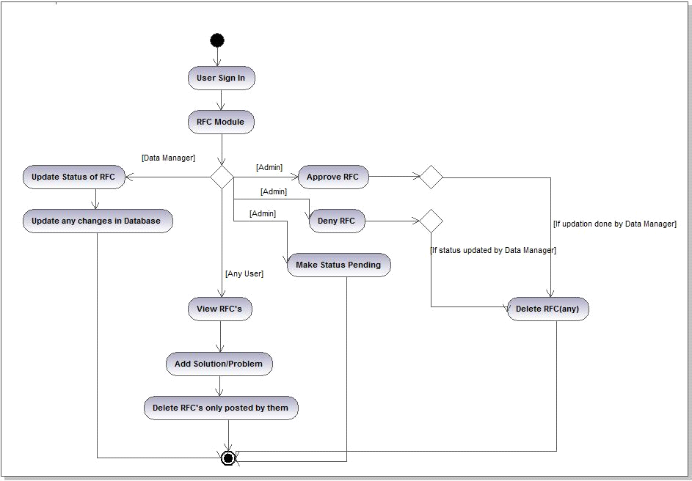

**Name of activity: -**Request For A Change**.**

**Description:** This is a module in which every user has a privilege of suggesting the admin for some minor or major change in the campus. Any user can add problem or solution to an existing problem. It’s the burden of Admin then to either approve it, deny it or even leave it pending.

**Preconditions:**

*  The User is logged in.

**Alternate flow of events:** None.

**Post Condition:**

* The Request is added in the database and left for admin to process it further.

**Name of activity: -**Generation of Status of books

**Description:** The admin can generate status of books by simply clicking on a button. The reports are generated through in excel and csv formats.

**Preconditions:**

*  The Admin is logged in.
* Status of books is updated in Database
* MS-EXCEL is installed.

**Alternate flow of events:** None.

**Post Condition:**

* The Status Report is generated.

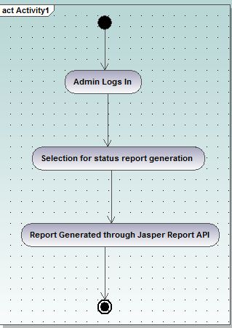

Name of activity: - WEB 2.0.

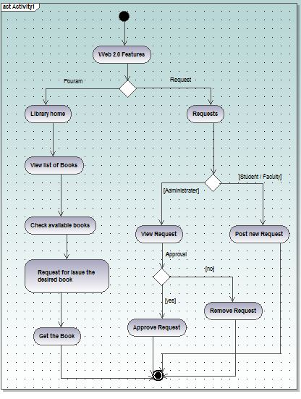

**Description:** WEB 2.0 support is used and the users are given facilities like forum, chatting and RSS feeds on notices.

**Preconditions:**

*  The User is logged in.
* Chat Server is started by the Data Manager.

**Alternate flow of events:** None.

**3.2** **Supplementary Requirements**:

* Have hours of operation that are 24x7 : Being an automated process, this system can work non-stop for all the time. This requires a UPS (Uninterruptible Power Supply) backup for atleast 8 hours
* Server Performance – The modern server is needed with advance features like load balancing, clustering, database connection pooling and caching.
* Session Management – The server should be inherently capable of handling sessions, so that the developer hs to be least worried about such trivial details.

**4.Key Features**

**4.1 Use of XML:-**

(a) Really Simple Syndication (RSS) :- **Module #10 Notices.**

(b) Extensible Stylesheet Transformation (XSLT)

(c) Use of XML datatype in DB2 database :- **DB2INST1.XMLTEST**

(d) Use of Ajax

(e) Xquery is used as a query language

(f) Service Oriented Architecture (SOA) is also used to expose useful modules as WebServices :- **Timetable Module#12** is provided as a Web Service.

**4.2 Plus Points in Design:-**

We have opted a modular approach in our coding though the use of **STRUTS(**a famous J2EE framework). The use of STRUTS has divided our project into separate modules which are complete in themselves and are independent of others that is providing **high cohesion and low coupling** to our project. The use of a **good directory structure** and **proper coding conventions** has added to the design features of our project.

Implementation of **SOA(** Service Oriented Architecture) in modules like **Time Table Generation** has even made our project more useful as these services can be easily integrated by any user outside the project and hence adds to the usability of the project running at one place but providing service at multiple centres.

Use of **RSS(**Really Simple Syndication) Feeds on the notices provides automatic notification to the subscribed users about any new notice that has been updated by the admin.

Use of **SSL(**Secure Socket Layer) for secure login of the user and thereby ensuring the security of the project.

Using many techniques for faster browsing of the Web Pages like **switching between HTTPS and HTTP,** use of **compression through JAVA**  and use of **XML as a data type in the database.**

The project can be quiet easily maintained as it is having a **central data source for database management.** The design is **architecture neutral** as there is use of **JAVA.** There is **application based management of resources** as switching between HTTPS and HTTP is completely controlled by the application itself and not by the container.

The **cost** of the project is also controlled by the **use of open source soft wares** which reduces installation and maintenance costs. **User ease** is also taken into account by providing very easy GUI for the user to interact. The use of **AJAX** at many places has made the project even more friendly and responsive to user.

|  |  |  |  |  |
| --- | --- | --- | --- | --- |
| **Number** | **Milestone Name** | **Milestone Description** | **Timeline**  Week no.  from the start  of the project | **Remarks** |
| 1 | Requirements Specification | Complete specification of the system (with appropriate assumptions) including the database design (for storing the books/journals details). A document detailing the same should be written and a presentation on that be made. | 1-2 | Attempt should be made to add some more relevant functionalities other than those that are listed in this document. |
| 2 | Technology familiarization | Understanding of the technology needed to implement the project. | 3-4 | The presentation should be from the point of view of being able to apply it to the project, rather than from a theoretical perspective. |
| 3 | High-level and Detailed Design | Listing down all possible scenarios (like searching for book/ journal, reserving a book/ journal, cancelling the reservation, submitting a purchase application for new books etc) and then coming up with flow-charts or pseudocode to handle the scenario. | 5-7 | The scenarios should map to the requirement specification (ie, for each requirement that is specified, a corresponding scenario should be there). |
| 4 | Implementation of the front-end of the system | Implementation of the main screen giving the login, screen that follows the login giving various options, screens for students/faculty and librarian for the various functions etc. | 7-9 | During this milestone period, it would be a good idea for the team (or one person from the team) to start working on a test-plan for the entire system. This test-plan can be updated as and when new scenarios come to mind. |
| 5 | Integrating the front-end with the database | The front-end developed in the earlier milestone will now be able to update the books/journal database. Other features like mail notification etc should be functional at this stage. In short, the system should be ready for integration testing. | 10-12 |  |
| 6 | Integration Testing | The system should be thoroughly tested by running all the testcases written for the system (from milestone 5). | 13-14 | Another 2 weeks should be there to handle any issues found during testing of the system. After that, the final demo can be arranged. |
| 7 | Final Review | Issues found during the previous milestone are fixed and the system is ready for the final review. | 15-16 | During the final review of the project, it should be checked that all the requirements specified during milestone number 1 are fulfilled (or appropriate reasons given for not fulfilling the same) |